哈尔滨工业大学计算学部
实验报告

课程名称：数据结构与算法
课程类型：专业基础（必修）
实验项目：树形结构及其应用
实验题目：哈夫曼编码与译码方法
实验日期：2021/10/25

设计成绩 | 报告成绩 | 指导老师
 |  | 张岩

一、实验目的
哈夫曼编码是一种以哈夫曼树（最优二叉树，带权路径长度最小的二叉树）为基础变长编码方式。其基本思想是：将使用次数多的代码转换成长度较短的编码，而使用次数少的采用较长的编码，并且保持编码的唯一可解性。在计算机信息处理中，经常应用于数据压缩。是一种一致性编码法（又称"熵编码法"），用于数据的无损耗压缩。要求实现一个完整的哈夫曼编码与译码系统。
二、实验要求及实验环境
实验要求：
1. 从文件中读入任意一篇英文文本文件，分别统计英文文本文件中各字符（包括标点符号和空格）的使用频率；
2. 根据已统计的字符使用频率构造哈夫曼编码树，并给出每个字符的哈夫曼编码（字符集的哈夫曼编码表）；
3. 将文本文件利用哈夫曼树进行编码，存储成压缩文件（哈夫曼编码文件）；
4. 计算哈夫曼编码文件的压缩率；
5. 将哈夫曼编码文件译码为文本文件，并与原文件进行比较；
6. 能否利用堆结构，优化的哈夫曼编码算法；
7. 上述1-5的编码和译码是基于字符的压缩，考虑基于单词的压缩，完成上述
工作，讨论并比较压缩效果；
8. 上述1-5的编码是二进制的编码，可以采用K叉的哈夫曼树完成上述工作，实现“K进制”的编码和译码，并与二进制的编码和译码进行比较。
实验环境：Sublime Text4编辑，gcc编译
三、设计思想（本程序中的用到的所有数据类型的定义，主程序的流程图及各程序模块之间的调用关系、核心算法的主要步骤）
1．逻辑设计
静态设计K叉哈夫曼树节点：
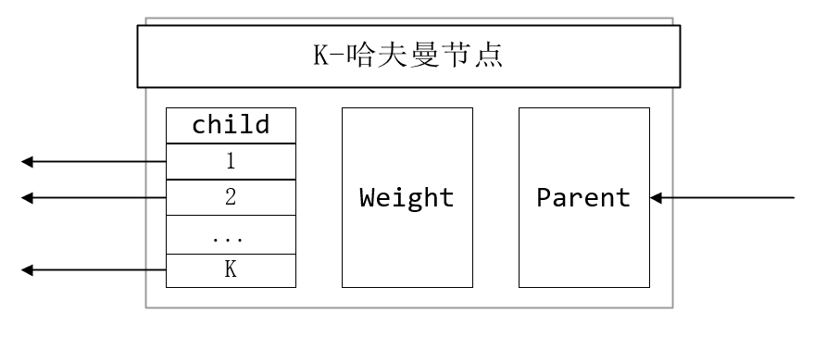
堆节点设计:
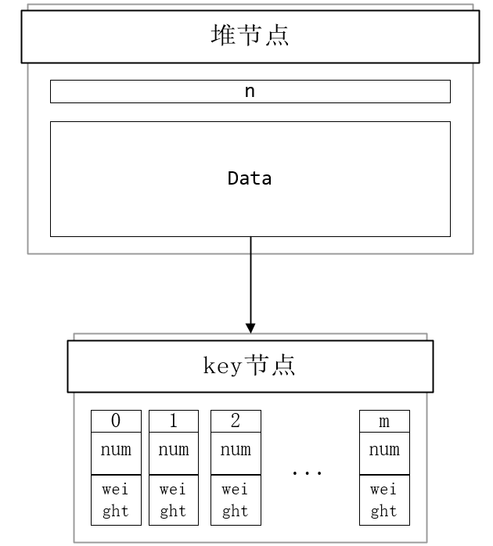
2．物理设计
程序流程图：
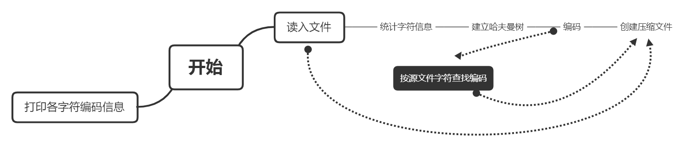

四、测试结果
原始文件：
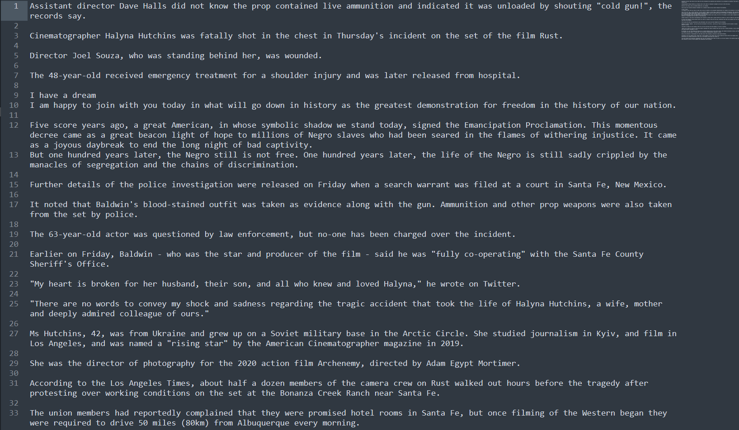
按字符编码读入文件并输出信息：
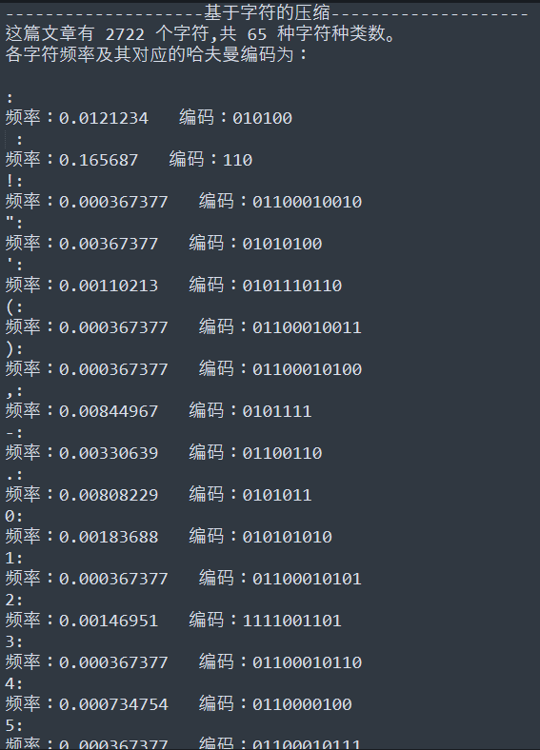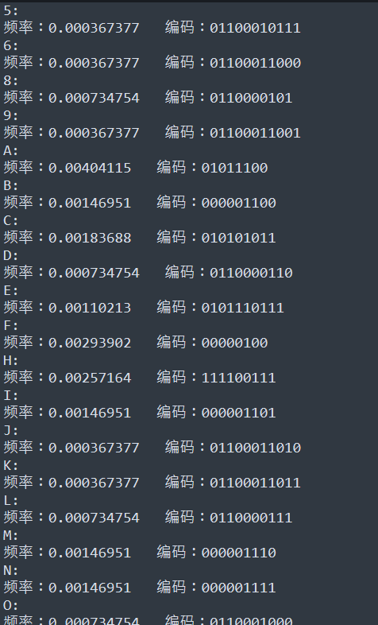
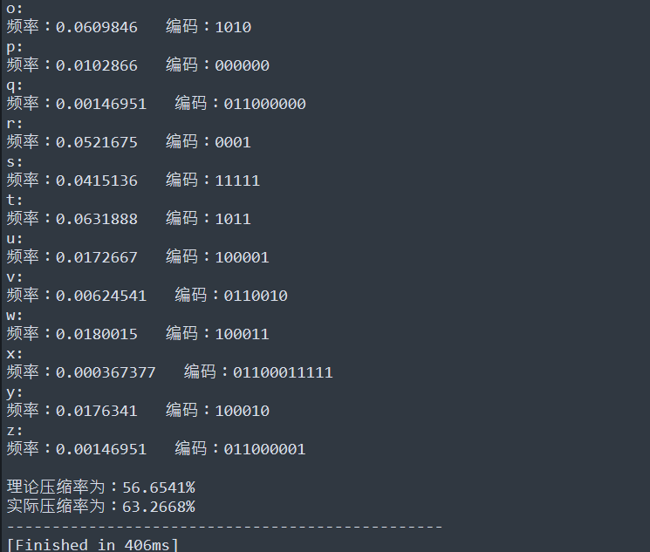
输出的二进制文件（16进制查看，仅截取部分）：
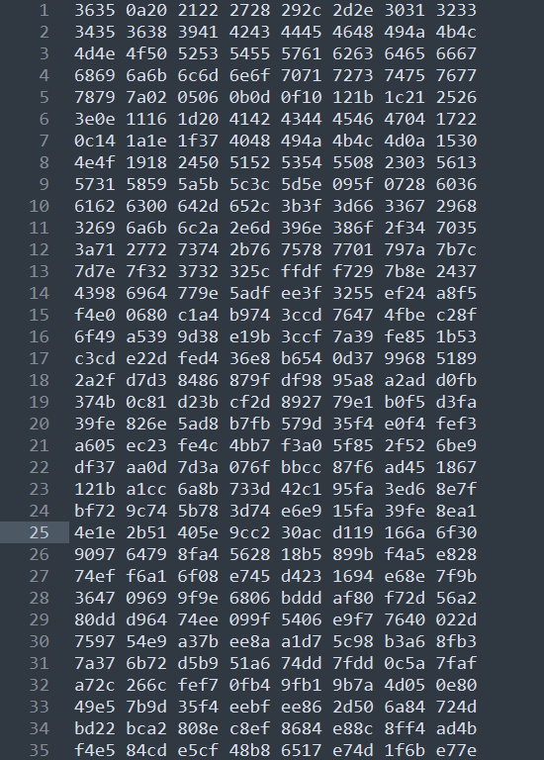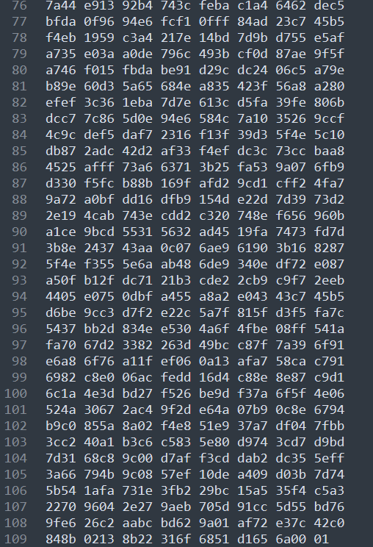
解压读取文件信息：
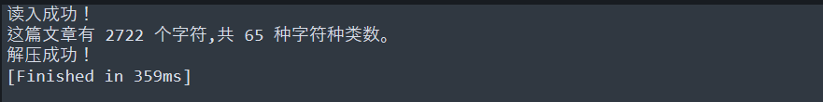
解压文件：
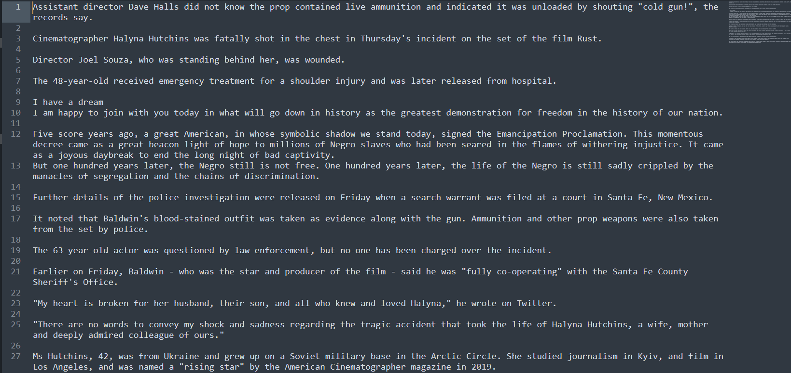
按单词编码读入文件并输出信息：
压缩,输出信息（仅截取部分）：
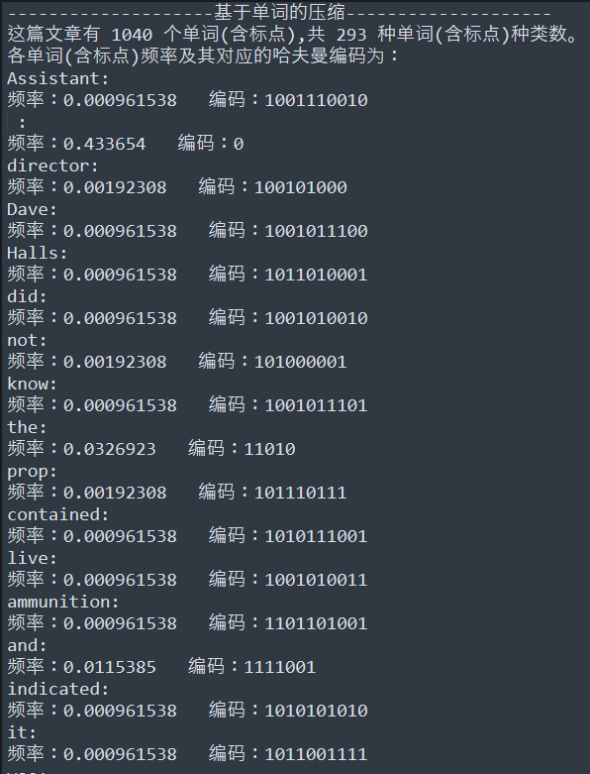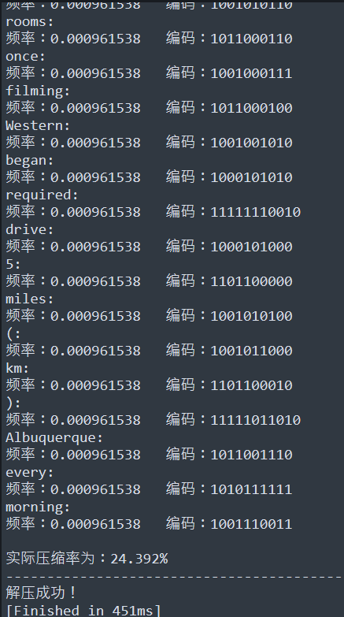
解压文件：
K-叉哈夫曼编码：
K=5(仅展示部分)：
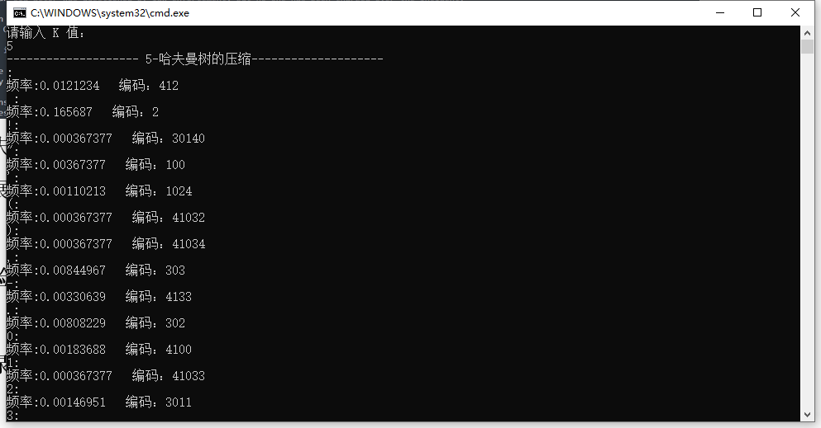
K=9(仅展示部分)：
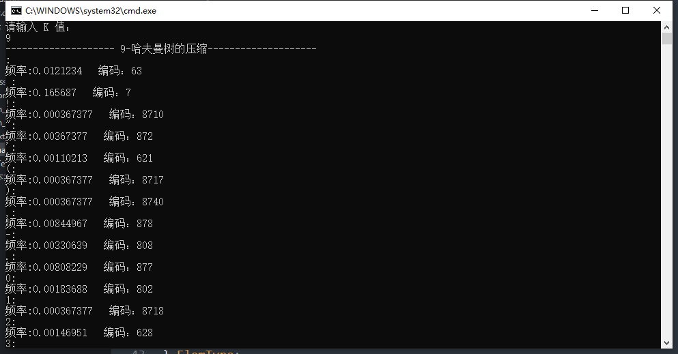
五、经验体会与不足
经验体会：
1、对哈夫曼算法的思想有了深刻的领悟；
2、对堆的应用有了更深的掌握，领悟到了这些数据结构对程序的优化作用；
3、从二叉树编码字符到K叉树编码单词，领悟到了程序由简单到复杂，逐步优化的设计过程。

不足：
全局变量应用过多，导致各函数模块的通用性不高程序的健壮性与可维护性不高。

六、附录：源代码（带注释）
- //基于字符编码
- #include <iostream>
- #include <fstream>
- #include <string>
- #include <string.h>
- #include <sys/stat.h>
- #include <iomanip>

- using namespace std;
- #define ASC 128
- #define m 2*ASC-1//2n-1个节点

- int totalch;//字符种类数
- long long countch;//总字符数

- typedef struct {
- double weight;
- int lchild;
- int rchild;
- int parent;
- } HTNode;

- typedef struct {
- char ch;//字符
- double freq;//字符频率
- char code[m];//哈夫曼编码
- } Orchar;

- HTNode HTree[m];
- Orchar Or[ASC];//记录各字符信息

- //分字符读文件，返回总字符数
- long long ReadFile(string &text) {
- ifstream file("InputText.txt");
- if (!file) {
- cout << "Failed To Open The File!" << endl;
- return 0;
- }
- int List[ASC] = {0};//频数
- char ch;
- long long i = 0;//总字符数
- int total = 0;//字符种类数
- while (file.get(ch)) {
- text += ch;//测试
- List[(int)ch]++;
- i++;
- }
- file.close();
- int p = 0;
- for (int k = 0; k < ASC; ++k) {
- if (List[k]) {
- total++;
- Or[p].ch = k;
- Or[p].freq = (double)List[k] / i;
- p++;
- }
- }
- totalch = total;//字符种类数
- return i;
- }
- //初始化结点值
- void InitHTree() {
- for (int i = 0; i < totalch; ++i)
- HTree[i].weight = Or[i].freq;
- for (int i = 0; i < m; ++i)
- {
- HTree[i].parent = -1;
- HTree[i].lchild = -1;
- HTree[i].rchild = -1;
- }
- }
- //选取两个最小数
- void SelectMin(int n, int& p1, int& p2) {
- int i, j;
- for (i = 0; i < n; ++i) {
- if (HTree[i].parent == -1) {
- p1 = i;
- break;
- }
- }
- for (j = i + 1; j < n; ++j) {
- if (HTree[j].parent == -1) {
- p2 = j;
- break;
- }
- }
- for (i = p1; i < n; ++i) {
- if ((HTree[p1].weight > HTree[i].weight) && (HTree[i].parent == -1) && (p2 != i))
- p1 = i;
- }
- for (j = p2; j < n; ++j) {
- if ((HTree[p2].weight > HTree[j].weight) && (HTree[j].parent == -1) && (p1 != j))
- p2 = j;
- }
- }
- //创建数
- void CreatHT() {
- int i, p1, p2;
- InitHTree();
- int n = totalch;
- for (i = n; i < 2 * n - 1; ++i)//0-n-1为字符
- {
- SelectMin(i, p1, p2);
- HTree[p1].parent = HTree[p2].parent = i;
- HTree[i].lchild = p1;
- HTree[i].rchild = p2;
- HTree[i].weight = HTree[p1].weight + HTree[p2].weight;
- }

- }
- //编码
- void CharSetHuffmanEncoding() {
- int c, p, i; //cp分别为孩子和双亲的位置
- char cd[ASC + 1]; //临时存放编码
- cd[totalch] = '\0';
- int start;//编码在cd中的位置
- for (i = 0; i < totalch; ++i) {
- start = totalch;
- c = i;
- while ((p = HTree[c].parent) >= 0) {
- cd[--start] = (HTree[p].lchild == c) ? '0' : '1'; //左0右1
- c = p;//上溯
- }
- strcpy(Or[i].code, &cd[start]);
- }
- }
- //输出二进制文件
- void HuffmanConpress() {
- ifstream file("InputText.txt");
- char ch;
- if (!file) {
- cout << "Failed To Open The Original Text!" << endl;
- }
- ofstream bfile;
- bfile.open("CompressedFile.huffman", ios::binary);
- if (!bfile) {
- cout << "Failed To Open The Compressed Text!" << endl;
- }
- //解释数据
- bfile << totalch;
- for (int i = 0; i < totalch; i++)
- bfile << Or[i].ch;
- for (int i = totalch; i < 2 * totalch - 1; ++i)
- bfile << (unsigned char)HTree[i].lchild << (unsigned char)HTree[i].rchild; //左右结点
- bfile << countch;
- int t;//查找
- unsigned char bin = 0;//1字节
- int index;
- int bitindex = 0;
- while (file.get(ch)) {
- for (t = 0; t < totalch; t++) {
- if (Or[t].ch == ch) //查码
- break;
- }
- for (index = 0; Or[t].code[index]; ++index) {
- if (Or[t].code[index] == '0')
- bin = bin << 1;
- else
- bin = (bin << 1) + 1;

- bitindex++;
- if (bitindex == 8) {
- bfile << bin;
- bitindex = 0;
- bin = 0;
- }

- }
- }
- if (bitindex) { //最后不足8位
- bin = bin << (8 - bitindex);
- bfile << bin << (unsigned char)bitindex;
- }
- file.close();
- bfile.close();

- }
- //输出压缩信息
- void CompressInformantion(string text) {
- double Inbits = 8 * countch;
- double Outbits = 0;
- for (int i = 0; i < countch; i++) {
- int t;
- int j;
- for (t = 0; t < totalch; t++) {
- if (Or[t].ch == text[i]) //查码
- break;
- }
- for (j = 0; Or[t].code[j]; j++);
- Outbits += j;
- }
- cout << "理论压缩率为：" << (double)Outbits / Inbits * 100 << "%" << endl;
- struct _stat In, Out;
- _stat("InputText.txt", &In);
- _stat("CompressedFile.huffman", &Out);
- double Inbitst = In.st_size;
- double Outbitst = Out.st_size;
- cout << "实际压缩率为：" << (double)Outbitst / Inbitst * 100 << "%" << endl;
- }

- void test1() {
- string text;//文件读入字符串中
- countch = ReadFile(text);
- CreatHT();
- CharSetHuffmanEncoding();
- cout<<"--------------------基于字符的压缩--------------------"<<endl;
- cout << "这篇文章有" << " " << countch << " 个字符,共" << " " << totalch << " 种字符种类数。" << endl;
- cout << "各字符频率及其对应的哈夫曼编码为：" << endl;
- for (int i = 0; i < totalch; ++i) {
- cout << Or[i].ch << ":" << endl;
- cout << "频率：" << Or[i].freq << " " << "编码：" << Or[i].code << endl;
- }
- HuffmanConpress();
- cout<<endl;
- CompressInformantion(text);
- cout<<"------------------------------------------------"<<endl;
- }

- int main() {
- test1();
- return 0;
- }

- //译码器
- #include <iostream>
- #include <fstream>
- #include <string>
- #include <string.h>

- using namespace std;
- #define ASC 128
- #define m 2*ASC-1//2n-1个节点
- //第一位，编码总数total(char型)
- //下total位，字符(char型)
- //下total-1位，哈夫曼树(int型)
- int total;
- long long count;
- typedef struct {
- double weight;
- int lchild;
- int rchild;
- int parent;
- } HTNode;
- typedef struct {
- char ch;//字符
- double freq;//字符频率
- char code[ASC];//哈夫曼编码
- } Orchar;
- HTNode HTree[m];
- Orchar Or[ASC];
- int main(){
- ifstream bfile("CompressedFile.huffman",ios::binary);
- ofstream file("OutputText.txt");
- if(!bfile){
- cout<<"Failed To Open The Compressed File!"<<endl;
- return 0;
- }
- //字符种类数
- bfile>>total;
- bfile>>noskipws;//设置读取空白符
- //各字符
- for (int i = 0; i < total; ++i){
- bfile>>Or[i].ch;
- }
- //哈夫曼树节点
- for (int i = total; i < 2 * total - 1; ++i)//0-n-1为字符
- {
- unsigned char p1,p2;
- bfile>>p1>>p2;
- HTree[i].lchild = (int)p1;
- HTree[i].rchild = (int)p2;
- }
- //字符数
- bfile>>count;
- cout<<"读入成功！"<<endl;
- cout<<"这篇文章有"<<" "<<count<<" 个字符,共"<<" "<<total<<" 种字符种类数。"<<endl;
- unsigned char b1;
- bfile >> b1;
- int i = 0;
- int j = 2*total-2;
- int ccount = 0;
- while(ccount<count){
- if (((b1 >> (7 - i)) & 1))
- j = HTree[j].rchild;
- else
- j = HTree[j].lchild;
- ++i;
- if (j < total)
- {
- file << Or[j].ch;
- ccount++;
- j = 2 * total - 2;
- }
- if (i == 8)
- {
- i = 0;
- bfile>>b1;
- }
- }
- bfile.close();
- file.close();
- cout << "解压成功！" << endl;
- }

- //基于单词编码
- //堆优化
- #include <iostream>
- #include <fstream>
- #include <string>
- #include <string.h>
- #include <sys/stat.h>
- #include <iomanip>
- using namespace std;

- #define MaxWord 10000//最大单词种类数
- #define mw 2*MaxWord-1

- int totalword;//单词种类数
- long long countword;//总单词数

- typedef struct {
- double weight;
- int lchild;
- int rchild;
- int parent;
- } HTNode;

- typedef struct {
- string word;//单词
- double freq;//单词频率
- char code[MaxWord];//哈夫曼编码
- } Orword;

- HTNode HTreew[mw];
- Orword Ow[MaxWord];

- //堆结构
- //最小堆
- typedef struct {
- int num;//与Orword对应
- double weight;
- } ElemType;
- typedef struct{
- ElemType data[mw];
- int n;
- }heap;
- //堆功能
- void InitHeap(heap& heap);//初始化
- bool isHeapEmpty(heap heap);//判空
- bool HeapFull(heap heap);//判满
- void HeapInsert(heap& heap, ElemType m);//插入
- ElemType HeapDeleteMin(heap& heap, int&num);//删除最小

- void Initheap(heap& heap){
- heap.n = 0;
- }
- bool isHeapEmpty(heap heap){
- return (!heap.n);
- }
- bool HeapFull(heap heap){
- return (heap.n == MaxWord - 1);
- }

- void HeapInsert(heap& heap, ElemType m){
- int i;
- if (!HeapFull(heap))
- {
- i = ++heap.n;
- while ((i != 1) && (m.weight < heap.data[i / 2].weight))
- {
- heap.data[i] = heap.data[i / 2];
- i /= 2;
- }
- }
- heap.data[i].num = m.num;
- heap.data[i].weight = m.weight;
- }
- ElemType HeapDeleteMin(heap& heap){
- int parent = 1, child = 2;
- ElemType tmp,elem;
- if (!isHeapEmpty(heap))
- {
- elem = heap.data[1];
- tmp = heap.data[heap.n--];
- while (child <= heap.n)
- {
- if ((child < heap.n) && (heap.data[child].weight > heap.data[child + 1].weight))
- ++child;
- if (tmp.weight <= heap.data[child].weight)
- break;
- heap.data[parent] = heap.data[child];
- parent = child;
- child *= 2;
- }
- }
- heap.data[parent] = tmp;
- return elem;
- }
- void CreatHeap(heap& heap){
- Initheap(heap);
- for(int i = 0;i<totalword;i++){
- ElemType m;
- m.num = i;
- m.weight = Ow[i].freq;
- HeapInsert(heap,m);
- }
- }

- //单词操作，返回总单词数
- long long ReadFileWord() {
- string t;//将文本保存到字符串
- string w;//读取单词
- ifstream file("InputText.txt");
- if (!file) {
- cout << "Failed To Open The File!" << endl;
- return 0;
- }
- long long j = 0;//总字符与单词数
- char ch;
- while (file.get(ch)) {
- t += ch;
- }
- w = "";
- int i = 0;
- while (t[i]) {
- w = "";
- if (t[i] >= 'A' && t[i] <= 'z') {//如果这个字符为字母，开始记录
- while (t[i] >= 'A' && t[i] <= 'z') {
- w = w + t[i];
- i++;
- }
- j++;
- }
- else {
- w = t[i];//标点，直接记录
- i++;
- j++;
- }
- int index = 0;
- int flag = 0;
- while (Ow[index].word != "") {
- if (Ow[index].word == w) {
- Ow[index].freq++;//freq在这里为频数
- flag = 1;
- break;
- }
- else {
- index++;
- }
- }
- if (flag == 0) {
- totalword++;
- Ow[index].word = w;
- Ow[index].freq++;
- }
- }
- file.close();
- return j;
- }
- //利用堆找两个最小值
- void SelectMinword(heap& heap,int& p1, int& p2) {
- p1 = HeapDeleteMin(heap).num;
- p2 = HeapDeleteMin(heap).num;
- }
- // void SelectMinword(int n, int& p1, int& p2) {
- // int i, j;
- // for (i = 0; i < n; ++i) {
- // if (HTreew[i].parent == -1) {
- // p1 = i;
- // break;
- // }
- // }
- // for (j = i + 1; j < n; ++j) {
- // if (HTreew[j].parent == -1) {
- // p2 = j;
- // break;
- // }
- // }
- // for (i = p1; i < n; ++i) {
- // if ((HTreew[p1].weight > HTreew[i].weight) && (HTreew[i].parent == -1) && (p2 != i))
- // p1 = i;
- // }
- // for (j = p2; j < n; ++j) {
- // if ((HTreew[p2].weight > HTreew[j].weight) && (HTreew[j].parent == -1) && (p1 != j))
- // p2 = j;
- // }
- // }

- //初始化结点值
- void InitHTreeword() {
- for (int i = 0; i < totalword; ++i)
- HTreew[i].weight = Ow[i].freq;
- for (int i = 0; i < mw; ++i)
- {
- HTreew[i].parent = -1;
- HTreew[i].lchild = -1;
- HTreew[i].rchild = -1;
- }
- }
- //创建树
- void CreatHTword() {
- int i, p1, p2;
- InitHTreeword();
- heap heap;
- CreatHeap(heap);
- int n = totalword;
- for (i = n; i < 2 * n - 1; ++i)//0-n-1为字符
- {
- SelectMinword(heap,p1, p2);
- HTreew[p1].parent = HTreew[p2].parent = i;
- HTreew[i].lchild = p1;
- HTreew[i].rchild = p2;
- HTreew[i].weight = HTreew[p1].weight + HTreew[p2].weight;
- ElemType m;
- m.num = i;
- m.weight = HTreew[i].weight;
- HeapInsert(heap,m);
- }
- }
- //编码
- void WordSetHuffmanEncoding() {
- int c, p, i; //cp分别为孩子和双亲的位置
- char cd[MaxWord + 1]; //临时存放编码
- cd[totalword] = '\0';
- int start;//编码在cd中的位置
- for (i = 0; i < totalword; ++i) {
- start = totalword;
- c = i;
- while ((p = HTreew[c].parent) >= 0) {
- cd[--start] = (HTreew[p].lchild == c) ? '0' : '1'; //左0右1
- c = p;//上溯
- }
- strcpy(Ow[i].code, &cd[start]);
- }
- }
- //计算频率
- void ConvertFreq(){
- for(int i = 0;Ow[i].word!="";i++){
- Ow[i].freq = (double)Ow[i].freq/countword;
- }
- }
- void wordHuffmanConpress(){
- ifstream file("InputText.txt");
- char ch;
- if (!file) {
- cout << "Failed To Open The Original Text!" << endl;
- }
- ofstream bfile;
- bfile.open("CompressedFile.huffman", ios::binary);
- if (!bfile) {
- cout << "Failed To Open The Compressed Text!" << endl;
- }
- //无解释数据
- int t;//查找
- unsigned char bin = 0;//1字节
- int index;
- int bitindex = 0;
- string s;
- while (file.get(ch)) {
- s += ch;
- }
- string w = "";
- int i = 0;
- while (s[i]) {
- w = "";
- if (s[i] >= 'A' && s[i] <= 'z') {//如果这个字符为字母，开始记录
- while (s[i] >= 'A' && s[i] <= 'z') {
- w = w + s[i];
- i++;
- }
- }
- else {
- w = s[i];//标点，直接记录
- i++;
- }
- for (t = 0; t < totalword; t++) {
- if (Ow[t].word == w) //查码
- break;
- }
- for (index = 0; Ow[t].code[index]; ++index) {
- if (Ow[t].code[index] == '0')
- bin = bin << 1;
- else
- bin = (bin << 1) + 1;

- bitindex++;
- if (bitindex == 8) {
- bfile << bin;
- bitindex = 0;
- bin = 0;
- }

- }
- }
- if (bitindex) { //最后不足8位
- bin = bin << (8 - bitindex);
- bfile << bin << (unsigned char)bitindex;
- }
- file.close();
- bfile.close();
- }
- void CompressInformantionword(){
- struct _stat In, Out;
- _stat("InputText.txt", &In);
- _stat("CompressedFile.huffman", &Out);
- double Inbitst = In.st_size;
- double Outbitst = Out.st_size;
- cout << "实际压缩率为：" << (double)Outbitst / Inbitst * 100 << "%" << endl;
- }
- void test2() {
- countword = ReadFileWord();
- ConvertFreq();
- CreatHTword();
- WordSetHuffmanEncoding();
- cout<<"--------------------基于单词的压缩--------------------"<<endl;
- cout << "这篇文章有" << " " << countword << " 个单词(含标点),共" << " " << totalword << " 种单词(含标点)种类数。" << endl;
- cout << "各单词(含标点)频率及其对应的哈夫曼编码为：" << endl;
- for (int i = 0; i < totalword; ++i) {
- cout << Ow[i].word << ":" << endl;
- cout << "频率：" << Ow[i].freq << " " << "编码：" << Ow[i].code << endl;
- }
- wordHuffmanConpress();
- cout<<endl;
- CompressInformantionword();
- cout<<"------------------------------------------------"<<endl;
- //测试
- // double sum = 0;
- // for(int i = 0;Ow[i].word!="";i++){
- // cout<<Ow[i].word<<":"<<Ow[i].freq<<endl;
- // sum +=Ow[i].freq;
- // }
- // cout<<sum;
- }
- void DeCompressWord(){
- ifstream bfile("CompressedFile.huffman",ios::binary);
- ofstream file("OutputText.txt");
- if(!bfile){
- cout<<"Failed To Open The Compressed File!"<<endl;
- return;
- }
- bfile>>noskipws;//设置读取空白符
- unsigned char b1;
- bfile >> b1;
- int i = 0;
- int j = 2*totalword-2;
- int ccount = 0;
- while(ccount<countword){
- if (((b1 >> (7 - i)) & 1))
- j = HTreew[j].rchild;
- else
- j = HTreew[j].lchild;
- ++i;
- if (j < totalword)
- {
- file << Ow[j].word;
- ccount++;
- j = 2 * totalword - 2;
- }
- if (i == 8)
- {
- i = 0;
- bfile>>b1;
- }
- }
- bfile.close();
- file.close();
- cout << "解压成功！" << endl;
- }
- int main() {
- test2();
- DeCompressWord();
- return 0;
- }

- //基于字符编码
- //堆优化
- //K哈夫曼树
- #include <iostream>
- #include <fstream>
- #include <string>
- #include <string.h>
- #include <sys/stat.h>
- #include <iomanip>
- using namespace std;

- #define ASC 128
- #define m 2*ASC-1//2n-1个节点

- #define Max_K 9

- int k;//k值
- int totalch;//字符种类数
- int nn;//补0之后的字符种类数
- long long countch;//总字符数

- typedef struct {
- double weight;
- int child[Max_K];//K个子节点
- int parent;
- } HTNode;

- typedef struct {
- char ch;//字符
- double freq;//字符频率
- char code[m];//哈夫曼编码
- } Orchar;

- HTNode HTree[m];
- Orchar Or[ASC];

- //堆结构
- //最小堆
- typedef struct {
- int num;//与Orword对应
- double weight;
- } ElemType;
- typedef struct{
- ElemType data[m];
- int n;
- }heap;

- //堆功能
- void InitHeap(heap& heap);//初始化
- bool isHeapEmpty(heap heap);//判空
- bool HeapFull(heap heap);//判满
- void HeapInsert(heap& heap, ElemType t);//插入
- ElemType HeapDeleteMin(heap& heap, int& num);//删除最小

- void Initheap(heap& heap){
- heap.n = 0;
- }
- bool isHeapEmpty(heap heap){
- return (!heap.n);
- }
- bool HeapFull(heap heap){
- return (heap.n == m - 1);
- }

- void HeapInsert(heap& heap, ElemType t){
- int i;
- if (!HeapFull(heap))
- {
- i = ++heap.n;
- while ((i != 1) && (t.weight < heap.data[i / 2].weight))
- {
- heap.data[i] = heap.data[i / 2];
- i /= 2;
- }
- }
- heap.data[i].num = t.num;
- heap.data[i].weight = t.weight;
- }
- ElemType HeapDeleteMin(heap& heap){
- int parent = 1, child = 2;
- ElemType tmp,elem;
- if (!isHeapEmpty(heap))
- {
- elem = heap.data[1];
- tmp = heap.data[heap.n--];
- while (child <= heap.n)
- {
- if ((child < heap.n) && (heap.data[child].weight > heap.data[child + 1].weight))
- ++child;
- if (tmp.weight <= heap.data[child].weight)
- break;
- heap.data[parent] = heap.data[child];
- parent = child;
- child *= 2;
- }
- }
- heap.data[parent] = tmp;
- return elem;
- }
- void CreatHeap(heap& heap){
- Initheap(heap);
- for(int i = 0;i<totalch;i++){
- ElemType t;
- t.num = i;
- t.weight = Or[i].freq;
- HeapInsert(heap,t);
- }
- }

- //利用堆找 K 个最小值
- void SelectMinword(heap& heap,int p[]) {
- for(int i = 0;i<k;i++){
- p[i] = HeapDeleteMin(heap).num;
- //cout<<p[i]<<endl;
- }
- }

- //读文件
- long long ReadFile(){
- ifstream file("InputText.txt");
- if (!file) {
- cout << "Failed To Open The File!" << endl;
- return 0;
- }
- int List[ASC] = {0};//频数
- char ch;
- long long i = 0;//总字符数
- int total = 0;//字符种类数
- while (file.get(ch)) {
- List[(int)ch]++;
- i++;
- }
- file.close();
- int p = 0;
- for (int k = 0; k < ASC; ++k) {
- if (List[k]) {
- total++;
- Or[p].ch = k;
- Or[p].freq = (double)List[k] / i;
- p++;
- }
- }
- totalch = total;//字符种类数
- return i;
- }
- //初始化节点值
- void InitHTree(){
- for (int i = 0; i < totalch; ++i)
- HTree[i].weight = Or[i].freq;
- for (int i = totalch; i < 2*totalch-1; ++i)
- HTree[i].weight = 0;
- for (int i = 0; i < m; ++i){
- HTree[i].parent = -1;
- for (int j = 0; j < k; ++j){
- HTree[i].child[j] = -1;
- }
- }
- }
- //创建树
- void CreatHTree() {
- int i = totalch;
- InitHTree();
- heap heap;
- CreatHeap(heap);
- int n = totalch;
- //第一次取 k 个，后面相当于取k-1个数，剩余部分补0
- if ((n - 1) % (k - 1)) {
- for (int i = 0; i < (k - 1) - (n - 1) % (k - 1); ++i){
- ElemType t;
- t.num = -1;
- t.weight = 0;
- HeapInsert(heap, t);
- }
- }
- //现在有 n + (k - 1) - (n - 1) % (k - 1)个叶节点
- nn = n + (k - 1) - (n - 1) % (k - 1);
- //非叶节点有 (nn-1)/(k-1) 个
- for (i = n; i < n + (nn-1)/(k-1) - 1; ++i){
- int p[Max_K];//最小权值节点
- SelectMinword(heap,p);
- for (int j = 0; j < k; ++j){
- HTree[p[j]].parent = i;
- HTree[i].child[j] = p[j];
- HTree[i].weight += HTree[p[j]].weight;
- }
- ElemType t;
- t.num = i;
- t.weight = HTree[i].weight;
- HeapInsert(heap,t);
- }
- }
- //编码
- void SetHuffmanEncoding() {
- int c, p, i; //cp分别为孩子和双亲的位置
- char cd[m + 1]; //临时存放编码
- cd[totalch] = '\0';
- int start;//编码在cd中的位置
- for (i = 0; i < totalch; ++i) {
- start = totalch;
- c = i;//c用来遍历叶子节点
- //cout<<HTree[c].parent<<endl;
- while ((p = HTree[c].parent) >= 0) {
- int j;
- for(j = 0;j<k;j++){
- if(HTree[p].child[j] == c)
- break;
- }
- cd[--start] = j+'0';//第j个儿子
- c = p;//上溯
- }
- strcpy(Or[i].code, &cd[start]);
- }
- }
- void test(){
- countch = ReadFile();
- CreatHTree();
- SetHuffmanEncoding();
- printf("-------------------- %d-哈夫曼树的压缩--------------------",k);
- for (int i = 0; i < totalch; ++i){
- cout<< Or[i].ch<<":"<<endl;
- cout<<"频率:"<<Or[i].freq<<" "<<"编码："<<Or[i].code<<endl;
- }
- }
- int main(void){
- cout<<"请输入 K 值："<<endl;
- cin>>k;
- test();
- }

